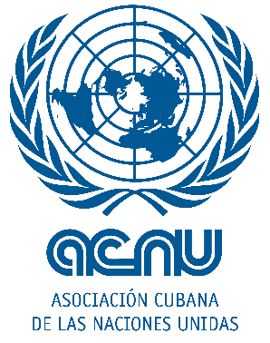

Declaration of the Cuban Association of United Nations on the occasion of the International Day of Peace

Every September 21, since 1981, the International Day of Peace is celebrated around the world. An initiative of the United Nations (UN) that seeks to raise awareness about non-violence and the ceasefire at the international level.

This year, the celebration is marked by the pandemic caused by the new SARS-COV-2 coronavirus, which has come to show that we are not enemies from each other, but the virus itself is our only adversary.

The human and material losses are enormous, while the challenge of overcoming this

pandemic is even greater. Likewise the UN, we understand that only solidarity between

the peoples of the world will contribute to generate better solutions to emerge triumphant from this new prevailing situation.

In recent months the Cuban people have given ample proof of a vocation of solidarity and pacifism. The international contingent of doctors specialized in disaster situations and serious epidemics "Henry Reeve" is a convincing example of this purpose by promoting the human right to peace and defending the full enjoyment of rights derived from the inherent dignity of all human beings, which includes the right to life.

The humanism and solidarity promoted by these health workers ratifies the dignity of the human being, based on equality and social justice and contributes to the development of peoples, in particular, by providing health for all.

For this reason, from the Cuban Association of the United Nations, we join the motto

of the campaign launched by the UN for this significant date: “Together forging peace”.

Forging peace together involves enormous responsibility and empathy with our fellow men and women. It is inconceivable to achieve this if even in the midst of the complex situation we face, governments such as the United States of America (USA) that insist on maintaining and enforcing severe and unjust unilateral coercive measures against nations like ours, which undermine the desire of many to achieve a better world.

We Cubans, will maintain our denunciation of the genocidal blockade that for more than 60 years is trying to steal our dreams of social justice and world peace.

We are convinced that together we can achieve the world of peace to which we aspire and the peoples for so long have fought.

If we work together, together we can forge peace!

Havana, September 21, 2020